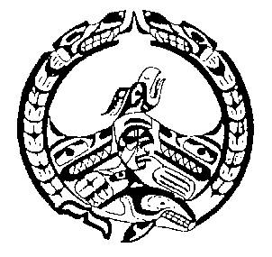
Nuchatlaht First Nation
Membership Support Application
j
The Membership Support application is made available for our membership to access emergency funding to ease financial hardship during difficult times. Members can expect a maximum amount of $200.00 once their application has been approved. You may apply for Membership support on behalf of your children.
Applications can be submitted once per fiscal year, and once per member. (April 2022- March 2023)
Name: | Status Number: 639- | Date:
Street Address: | City: | Postal Code:
Contact Number: | Email:
I am applying to be considered for Membership Support funds for the following reason:
Is your Direct Deposit up to date with our office? Yes: ☐ No: ☐ Unsure: ☐
If you chose “No” or “Unsure”, please fill out our “Direct Deposit application” found on our website: www.nuchatlaht.com/forms
Please list any additional family members you would like included in this application:
Name: | Date of Birth: | Nuchatlaht Band Status Number:
 |  | 639 -
 |  | 639 -
 |  | 639 -
 |  | 639 -
Initial:
_______ I certify that I have exhausted every other avenue of income assistance and the Nuchatlaht Membership
support is my last alternative.
_______ I certify the above information to be true
Applicant’s Signature Date:
Band Administrator’s Signature Date:

